2013年湘西土家族苗族自治州初中毕业学业考试英语试题卷

姓名: 准考证号:
---------------------------------------------------------------------------------------------------------------------------
注意事项:
1．本卷为试题卷，考生应在答题卡上作答，在试题卷、草稿纸上答题无效。
2．答题前，考生须先将自己的姓名、准考证号分别在试题卷和答题卡上填写清楚。
3．答题完成后，请将试题卷、答题卡、草稿纸放在桌上，由监考老师统一收回。
4．本试卷共四道大题，满分120分，时量90分钟。

I．听力技能 (共三节，计20分)

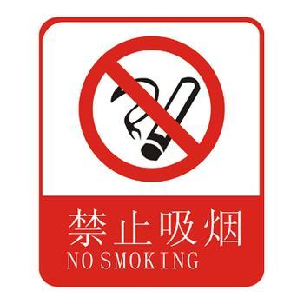
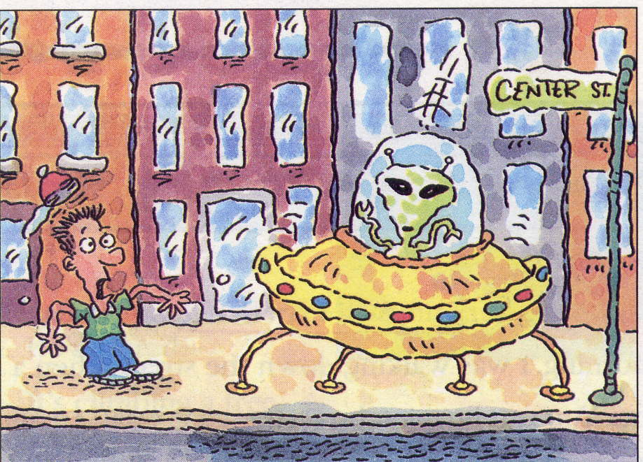
第一节 听音选图 根据所听内容，选择相应的图画。听每个句子前，你将有时间阅读各个小题，每小题5秒钟；听完后，各小题将给出5秒钟的作答时间。（共5小题，每小题1分）

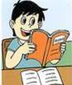

A B C D E
第二节 对话理解 听下面的对话，从题中所给的A、B、C三个选项中选出最佳答案。听每段对话前，你将有时间阅读各个小题，每小题5秒钟；听完后，各小题将给出5秒钟的作答时间。（共10小题，每小题1分）
听下面的对话，回答第6小题
6. What does Lucy’s father do?
A. He is a teacher. B. He is a doctor. C. He is a scientist.
听下面的对话，回答第7小题
7. What does John collect?
A. Stamps. B. Coins. C. Shells.
听下面的对话，回答第8小题
8. How will Kate go to school today?
A. By bus. B. By train. C. By car.
听下面的对话，回答第9小题
9. When is Ed’s father leaving for New York?
A. On January 1st. B. On January 2nd. C. On January 3rd.
听下面的对话，回答第10小题
10. What will the weather be like tomorrow?
A. Sunny. B. Rainy. C. Cloudy.
听下面的对话，回答第11—12小题
11. Where has Jim gone for his holiday?
A. To Hong Kong. B. To Beijing. C. To Paris.
12. Who did David go to Paris with?
A. His brother. B. His parents. C. His sister.
听下面的对话，回答第13—15小题
13. How long did Vince skate today?
A. About 4 hours. B. About 6 hours. C. About 5 hours.
14. When did Vince begin skating?
A. At the age of 5. B. At the age of 6. C. At the age of 7.
15. Who gave Vince the first pair of skates(滑冰鞋)?
A. His father. B. His uncle. C. His grandmother.
第三节 笔录要点 根据你听到的短文，将下面表格中第16至第20小题的信息补充完整，每小题不超过三个单词。（共5小题，每小题1分）
Rules in Mary’s House
● She has to get up at 16 o’clock every morning.
● She has to read Chinese and 17 before breakfast.
● She can’t 18 or play computer 19 on school nights.
● She has to do her 20 after school.

笔试部分（100分）
Ⅱ 知识运用（共两节，计25分）
第一节 单项选择 从A, B, C三个选项中选出最佳答案填空（共15小题，计15分）
21. —_____ is the red shirt? —It’s 50 yuan.
A. How much B. How many C. How old
- It’s getting dark. I _____ go home now.
A. can B. would C. have to
- Liu Ying is as _____ as her sister.
A. tall B. taller C. the tallest
- Could you tell me the way _____ the zoo?
A. on B. to C. in
- —Where’s Mr Green? —He _____ to Changsha.
A. have been B. has gone C. has been
- If it doesn’t rain tomorrow, we _____ swimming.
A. go B. will go C. went
27. Today is Tony’s birthday. It’s his _____ birthday.
A. 11 B. 11st C. 11th
- —Hi, Tom! A math book is on the teacher’s desk. Whose is it?
—I think it’s Mary’s. Because _____ name is on the book.
A. his B. her C. my
- Do you think there _____ robots in People’s homes in the future?
A. will be B. will is C. be will
- Would you mind _____ basketball here?
A. playing B. to play C. play
- _____ you have to wear a uniform at school?
A. Do B. Does C. Are
- What a fine day! Why not _____ outside?
A. having a walk B. to have a walk C. have a walk
- —How do you study for a test? —I study _____ listening to tapes.
A. at B. by C. to
- —When was the car invented? —It _____ in 1885.
A. invented B. is invented C. was invented
- —Where would you like to visit? — I’d like to go _____.
A. relaxing somewhere B. somewhere relaxing C. relaxing anywhere

第二节 完形填空 通读下面的短文，掌握其大意，然后从每小题所给的A,B,C三个选项中选出一个最佳答案。（共10小题，计10分）
I had a very unusual experience（经历）on Sunday. At ten in the morning, I was 36 down the street when a UFO landed right 37 of me. You can imagine（想象） 38 strange it was! An alien 39 and walked down Center Street. I followed it to see 40 it was going, and I was very surprised when it went 41 a souvenir shop. While it was 42 at the souvenirs（纪念品）, the shop assistant called the 43 . Before the police arrived, the alien left the 44 and then visited the Museum of Flight. 45 the alien was in the museum, I called the TV station. Isn’t that amazing!
36. A. arriving B. walking C. looking
37. A. in front B. before C. at
38. A. what B. when C. how
39. A. got in B. got on C. got out
40. A. where B. when C. which
41. A. onto B. on C. into
42. A. walking B. looking C. giving
43. A. police B. teacher C. driver
44. A. school B. shop C. street
45. A. While B. What C. Which

Ⅲ 阅读技能 （共四节，计40分）
第一节 阅读判断 阅读短文，判断下列句子是否符合短文内容。符合的选T， 不符合的选F。（共5小题，计10分）
My dream job
When I grow up, I’m going to do what I want to do. I’m going to move somewhere interesting. Paris（巴黎） sounds like a city that I could enjoy. There are lots of art exhibitions（艺术展） there. I want to be an artist. So how am I going to do it? First, I’m going to find a part-time job for a year or two and save some money. And I’m going to be a student at art school in Paris. And I want to learn French at the same time. Next, I’m going to hold（举办） art exhibitions because I want to be rich and buy a big house for my parents. I also want to travel all over the world. One day, I’m going to retire（退休） somewhere quiet and beautiful.

46. Paris sounds like a city that I could enjoy.
47. I want to be an artist.
48. I want to learn English at the same time.
49. I want to be rich and buy a big house for my parents.
50. I don’t want to travel all over the world.

第二节 阅读选择 阅读表格内容，从每小题所给的A,B,C三个选项中，选出最佳选项回答问题或完成句子。（共5小题，计10分）
Travel Information
Place of interest  (景点) | Fenghuang Ancient Town | Mount Bamian  (八面山) | Zhang Jiajie Forest Park
Location  (位置) | Fenghuang County（县） | Longshan County | Zhang Jiajie District (地区)
Phone Number | 8228386 | 8323452 | 8572190
Price of Ticket | 150yuan | 120yuan | 320yuan
Famous sights | Old buildings by a beautiful Tuo River | The grassland on the top of the mountain | A famous forest park

51. You can visit a famous forest park in .
A. Fenghuang B. Mount Bamian C. Zhang Jiajie
52. If you don’t know how to get to Mount Bamian, you can call .
A. 8228386 B. 8323452 C. 8572190
53. If you want to visit Fenghuang Ancient Town, you need to pay .
A. 150yuan B. 120yuan C. 320yuan
54. Fenghuang is famous for .
A. Old buildings B. Mount Bamian C. a forest park
55. is the most expensive of the three.
A. Mount Bamian B. Zhang Jiajie Forest Park C. Fenghuang

第三节 阅读匹配 阅读下面短文，从所给的A—E五个选项中，选出正确的选项填空，使短文通顺、内容完整。（共5小题，计10分）
He used to cause （引起）a lot of trouble.
Martin Murray is a fifteen-year-old boy. He used to be a “problem child”, but a recent conversation with his mother changed his life. He didn’t use to give his mother many problems. However, after his father’s death a few years ago, 56 . His mother couldn’t afford to pay（不能负担） her child’s education. To do this, she had to work, and so was often not at home.
His mother looked after him as well as she could. Unfortunately, Martin still caused problems for himself and his family. He was not interested in studying and he often got into trouble with（与…冲突） the police. Luckily, his mother was very patient（有耐心的）
57 . In the end, she made a difficult decision: to send him to a boys’ boarding school. Martin hated it and used to cause a lot of trouble. One day he told his teacher he wanted to leave the school. 58 .
But the head teacher（班主任）said it was necessary for Martin to talk with his mother. Martin called his mother, but to his surprise, this phone call changed his life. “It was exactly what I needed,” he said. “My mother helped me to understand how much she had given me. She also told me that even though my father was no longer（不再） with us, he was watching me and would always take pride in（对…感到自豪） everything good I do. 59 . I realize that since my father died, I have been afraid of being alone, and have tried to make my mother pay more attention to（多注意）me.”
Now Martin has really changed. He has been working hard and is now one of the best students in his class. 60 ? His mother’s love helped him to feel good about himself, and as Martin himself says, “It’s very important for parents to be there for their children.”
A: How was he able to change?
B: and she didn’t give up(放弃) trying to help him.
C: That’s when I decided to change.
D: Martin’s life became much more difficult.
E: His teacher agreed him to leave and thought Martin was wasting his time(浪费时间).
第四节 阅读摘录 阅读下面短文，根据短文内容，完成表格中所缺的信息。（共5小题，计10分）
This week we asked students at New Star High School about the best ways to learn more English. Some said they learnt by using English. Some students had more specific suggestions(具体的建议).
Lillian Li said the best way to learn new words was by reading English magazines. She said that she never studied grammar. She thought it was too boring.
Wei Ming feels differently. He’s been learning English for six years and really loves it. He thinks studying grammar is a great way to learn a language. He also thinks that watching English movies is a good way to watch the actors say the words.
Liu Chang said that joining the English club at school was the best way to improve her English. Students get lots of practice and they also have fun.

Students | Their 61 suggestions
Lillian Li | ★ 62 English magazines is the best way to learn new words.
Wei Ming | ★ 63 grammar is a great way to learn a language.  ★Watching English 64 is a good way to watch the actors say the words.
Liu Chang | ★Joining the English club at school was the best way to 65 her English.

Ⅳ 写作技能。（共三节，计35分）
第一节 阅读简答 阅读短文，然后根据短文内容简要回答下列问题。（共5小题，计10分） Class 9 had a great time on the school trip. They went to Blue Water Aquarium(水族馆) for the day. First they visited the Visitors’ Center and watched a movie about sharks. Then they watched a dolphin show. After that, they went to the Outdoor Pool and saw a big octopus(章鱼). After lunch, they went to the Gift Shop and bought lots of gifts. Finally, tired but happy, they took the bus back to school. At the end of the day, the science teacher was very happy because the class monitor cleaned the bus after the trip.
66. Did the students have a great time on the school trip?
67. Where did they see an octopus?
68. How did they get back to school?
69. When did they go to the Gift Shop and buy lots of gifts?
70. Who cleaned the bus after the trip?

第二节 双向翻译 阅读下面短文，将文中划线部分译成汉语或者英语。（共5小题，计10分）
My biggest problem is that （71）I’m too busy. When I was young, I used to have so much time, but these days （72）我早早起床and stay in school all day. Then I go right home and eat dinner. Before I started high school, （73）I used to spend a lot of time playing games with my friends, but now I don’t have the time anymore. （74）我喜欢音乐, and my father used to take me to concerts. These days, I hardly ever have time for concerts. I do my homework and go to bed. （75）I really miss the old days.

第三节 书面表达 （计15分）
近20年来各方面调查表明青少年体质的下降令人担忧。请你以How to keep healthy为题，写一篇60—80词的短文，说说你的看法和建议。
要求：主要包括以下内容，可以适当发挥。开头已给出，不计入总词数。
1. 体质下降的原因; 如：eat too much junk food , have too much homework, …
2. 合理的健康建议。如：some useful advice, should do more exercise, eat a balanced diet（饮食平衡), enough sleep…
How to keep healthy
Nowadays students physical fitness is declining(体质下降) year by year. I think there are some reasons.

2013年湘西土家族苗族自治州初中毕业学业考试英语听力材料

2013年湘西自治州初中毕业学业考试英语听力测试现在开始。所有的听力材料将以中速朗读两遍。请同学们做好准备。
第一节 听音选图 根据所听内容，选择相应的图画。听每个句子前，你将有时间阅读各个小题，每小题5秒钟；听完后，各小题将给出5秒钟的作答时间。（共5小题，每小题1分）
1. It’s raining now.
2. Yao Ming is taller than Jordan.
3. You are not allowed to smoke here.
4. The boy was walking down the street when a UFO landed.
5. What is the boy doing? He is reading a book.
第二节 对话理解 听下面的对话，从题中所给的A、B、C三个选项中选出最佳答案。听每段对话前，你将有时间阅读各个小题，每小题5秒钟；听完后，各小题将给出5秒钟的作答时间。（共10小题，每小题1分）
听下面的对话，回答第6小题
M: What does your father do, Lucy?
W: He is an English teacher.
听下面的对话，回答第7小题
W: Hi, John! These shells are so beautiful. Are they yours?
M: Yes, my hobby is collecting shells.
听下面的对话，回答第8小题
M: Kate! It’s 8 o’clock now. You’ll be late for school.
W: Yes, and I have to take a bus to school.
听下面的对话，回答第9小题
W: When is your father leaving for New York, Ed?
M: He is leaving on New Year’s Day.
听下面的对话，回答第10小题
W: Let’s go to the park for a picnic tomorrow, shall we?
M: I’m afraid not. The radio says it will be rainy tomorrow.
听下面的对话，回答第11—12小题
W: Where’s Jim, David?
M: He has gone to Paris for his holiday.
W: Have you ever been to Paris?
M: Yes. I went there with my parents last year.
W: How did you go there?
M: We went there by plane.
听下面的对话，回答第13—15小题
W: Vince, congratulations on winning the skating Marathon.
M: Thank you, Anna!
W: So, how long did you skate today?
M: About six hours.
W: How amazing! Was this your first skating Marathon?
M: No, I skated in the Marathon last year.
W: How long have you been skating?
M: Since I was seven years old.
W: That’s such a long time!
M: Yes, it is.
W: Who did you get your first skates from?
M:I got my first pair of skates on my seventh birthday from my grandmother.
第三节 笔录要点 根据你听到的短文，将下面表格中第16至第20小题的信息补充完整，每小题不超过三个单词。听材料前，你将有25秒钟阅读表格内容。听完后，将给出25秒钟的作答时间。（共5小题，每小题1分）
There are so many rules in Mary’s house. She has to get up at 6:00 o’clock every morning and read Chinese and English before breakfast. She can’t watch TV or play computer games on school nights. She has to do her homework after school. She has too much homework every day.

(50 words)

听力测试完毕，请同学们继续答题。监考老师，请关机。

2013年湘西土家族苗族自治州初中毕业学业考试英语参考答案

Ⅰ. 听力（共三节，计20分）
1—5 BCEAD 6—10 ACAAB 11—15 CBBCC
16. six/6 17. English 18. watch TV 19. games 20. homework
Ⅱ. 知识运用（共两节，计25分）
- 选择题（共15小题，计15分）
21—25 ACABB 26—30 BCBAA 31—35 ACBCB
- 完形填空。（共10小题，计10分）
36—40 BACCA 41—45 CBABA
Ⅲ. 阅读技能 （共四节，计40分）
第一节 阅读判断 （共5小题，计10分）
46—50 TTFTF
第二节 阅读选择 （共5小题，计10分）
51—55 CBAAB
第三节 阅读匹配 （共5小题，计10分）
56—60 DBECA
第四节 阅读摘录 （共5小题，计10分）
61. specific 62. Reading 63. Studying 64. movies 65. improve
Ⅳ 写作技能。（共三节，计35分）
- 阅读简答 根据短文内容，回答下列问题。（10分）
66. Yes, they did. 67. At the Outdoor Pool. 68. They took the bus back to school./By bus.
69. After lunch. 70. The class monitor.
- 双向翻译 阅读下面的短文，请根据上下文内容，将文中划线部分译成汉语或者英语。（共5小题，计10分）
71.我太忙了。
72. I get up early.
73.我过去常花很多时间和朋们玩游戏。
74. I love music
75.我真想念以前的日子。
第三节 书面表达 （15分）
How to keep healthy
Nowadays students’ physical fitness is declining year by year. I think there are some reasons. Students have too much homework to do, so they have little time to have sports. Some students eat too much junk food . That’s also bad for their health.
Then, how to keep healthy? Here are some useful advice. First,students should do more exercise. Second, students should eat a balanced diet. They should eat more vegetables and fruits, and try to eat less junk food. Finally, enough sleep is also very important.

